AI BlogNest - Generate high-quality blog content using AI.

Description
AI BlogNest is an AI-powered blog management platform designed to make blog creation and content management easier and more efficient. The application allows users to create, manage, search, and organize blog posts with the assistance of Artificial Intelligence.
The backend of the system is developed using Node.js and Express.js, with MongoDB used as the database and Mongoose for data modeling and database operations. The application integrates Google Gemini AI to provide AI-assisted features such as blog content generation and FAQ generation, helping users create useful and relevant content with less manual effort.
The system provides secure user authentication using JWT (JSON Web Tokens), while bcrypt.js is used to securely encrypt user passwords. Users can perform various blog management operations such as creating, updating, viewing, and deleting blogs. The system also supports categories, tags, comments, media information, and blog searching.
To improve the security and reliability of the application, features such as input validation, input sanitization, rate limiting, error handling, and structured logging are implemented. These mechanisms help maintain secure and consistent communication between the client and server.
Overall, AI BlogNest combines traditional blogging features with Generative AI to provide a simple and efficient platform for creating and managing blog content. The project demonstrates the practical use of Node.js, Express.js, MongoDB, REST APIs, JWT authentication, and Google Gemini AI in developing a modern web-based application.

Scenario-Based Case Study
Background
Priya is a content creator who manages several blogs and regularly publishes new content. As the number of posts increases, she faces difficulties in organizing drafts, managing categories and tags, scheduling publications, and monitoring how readers interact with her content.
Problem
- Managing multiple blog drafts, categories, and tags becomes difficult and time-consuming.
- There is limited access to information about post performance and reader engagement.
- Content review, approval, and comment moderation require considerable manual effort.
- Managing uploaded media files and maintaining their related metadata is not handled through a unified system.
- Different users such as authors, editors, and administrators require different levels of access and permissions.
Solution
The BlogNest backend provides a centralized and secure REST API that separates the application's business logic from the frontend. It uses a structured permission system to control access to different services and operations. The backend supports content scheduling, category and tag management, media metadata handling, and role-based permissions for different types of users.
Usage
- Author Usage: Authors can create and manage blog posts, organize drafts, handle media information, and access relevant information about their published content.
- Editor/Admin Usage: Editors and administrators can access protected endpoints to review and manage content, update publication status, moderate comments, and manage user roles and permissions.
- Reader Usage: Readers can access publicly available blog posts through the appropriate API endpoints and can submit comments on published content.

Outcome
By centralizing content and workflow management within the backend, BlogNest helps make the blogging process more organized and efficient. Schema validation helps maintain data consistency, while authentication and role-based access control ensure that users can perform only the operations permitted for their roles. The system also maintains relevant content and engagement data, providing a structured foundation for monitoring and improving blog performance.

1. Software Requirements
- Operating System: Windows 10/11, macOS, or Linux (supports cross-platform operations).
- Node.js (v16 or above): Runtime ecosystem running server logic and routing infrastructure.
- npm (v8 or above): Node package manager to control operational dependencies.
- Express.js: Lightweight routing web framework to construct backend RESTful entry points.
- MongoDB: Document NoSQL engine storing users, posts, categories, comments, and analytics metrics.
- Postman: API verification toolkit to assert schema validation responses across administrative route shields.
- Code Editor: Visual Studio Code or similar IDE environment.

2. Hardware Requirements
- Processor: Intel Core i5 (8th Gen or above) / AMD Ryzen 5 or equivalent.
- RAM: 8 GB minimum (16 GB recommended for concurrent instances of MongoDB, processing layers, and execution nodes).
- Storage: 1 GB of available disk workspace.
Epic:-1 PROJECT ARCHITECTURE 

The BlogNest application exposes structured endpoints handled by a layered server architecture model. Incoming requests undergo filter processing before interacting with data services.

Components Definition
- Interface: API tools like Postman query distinct route paths to extract JSON entities.
- Express Server Gateway: Monitors network ports, maps explicit HTTP methods (GET, POST, PUT, DELETE), parses JSON payloads, and handles CORS headers.
- Authentication & Role Matrix Middleware: Extracts tokens from headers, validates user context signatures, and evaluates if the specific role satisfies authorization thresholds for guarded resource paths.
- Granular Services (Logic Modules): Enforces isolated domain rules for blog lifecycles (Draft, Pending Approval, Scheduled, Published), comment queues, and system reporting indicators.
- Database Interface Layer: Mongoose translates operational application logic into performant native MongoDB queries.
- AI Flow (Service Integration): Provides intelligent content automation, including automated blog post generation and real-time content summarization. This layer connects to external AI models via specialized endpoints (/api/ai/generate-blog and /api/ai/summarize), allowing the controller layer to offload complex text processing tasks and enhance content creation workflows.
- BlogGenerator with AI: A specialized service that automates the generation of blog content, which integrates with the AI Flow service to streamline the drafting process.

Entity-Relationship (ER) Diagram Description
The underlying document structure manages several collections bound by logical application references:


1. User Entity
- _id (Primary Key - ObjectId)
- name (String, Required)
- email (String, Required, Unique)
- password (String, Hashed, Required)
- role (String, Default: "reader")

2. Post Entity
- _id (Primary Key - ObjectId)
- userID (Foreign Key referencing User Collection)
- name (String, Required - represents Title)
- photo (Object/String pathway link)
- message (String - Core content body)
- likes (Number, Default: 0)
- timestamps (True)

Key Structural Mappings
- User to Post (One-to-Many): An author can submit multiple blog documents.
- User to Comment (One-to-Many): Readers/Users can append multiple response comments across independent post nodes.
- Post to Comment (One-to-Many): A single blog document stores individual referenced comment submissions.

Key Features
- Role-Based Route Guarding: Strict token processing blocks unauthorized tiers from modifying core settings.
- CRUD Blog Execution Engine: Complete schema management over content definitions, status states, and asset assignment paths.
- Categorization System: Native tag indices facilitate filtering and querying for enhanced discoverability.
- Comment Moderation Logic: Protected entry points for updating moderation flags (approved, pending, spam).
- Sanitization Safeguards: Payload parameter sanitation prevents XSS vectors and NoSQL parameter manipulation injections.
- I-Driven Blog Generation Pipeline: Integrates external Large Language Model (LLM) abstractions and context-aware prompt templates to synthesize full-length, structured blog posts from high-level thematic inputs.
- Intelligent Content Summarization Engine: Leverages semantic compression layers to parse extensive article payloads, dynamically generating concise abstracts and automated metadata summaries.

Roles and Responsibilities
- Admin: Has the highest level of access and manages the overall system. The Admin can manage user accounts, assign or modify user roles, remove inappropriate comments, and monitor system activities and logs.
- Editor: Responsible for managing the editorial process. The Editor can review submitted or pending blog posts, update their publishing status, and manage categories and related content.
- Author: Has limited access focused on content creation. Authors can create and manage blog posts associated with their own accounts, while access to administrative functions remains restricted.
- Reader: Has access to published blog content for reading and interaction. Readers can view available posts and submit comments using their authenticated accounts.
User Flow:


MVC Architecture Pattern
The system architecture structures its source configuration layers around the Model-View-Controller design pattern to completely decouple components: 

Model Layer (Data Blueprint)
Defines structure blueprints via strongly enforced Mongoose schemas mapping explicit fields into raw collection items inside MongoDB. It sets default states, indexing rules, and transformation parameters before validation persistence occurs.

Controller Layer (Execution Matrix)
The intermediary brain of the ecosystem. It captures request vectors from the execution routes, checks structural request constraints, delegates processing workflows directly to models, and packages the resultant output into standard JSON return arrays.

View Layer (Routing Network Interface)
In this pure headless backend service context, standard user-interface template views do not exist. Instead, the interface layer lives as an API Routing Layer. It links network requests on specified paths directly to their associated controller handler logic maps.

Epic2: Project Setup and Configuration

Creating project folder:

1. Create a new folder with your <project name>.
2. Inside that folder create one new folders.
3. Name another one as Server.
4. Now open that folder in VS Code.


Server setup (npm init)
  - Open Server folder in terminal of VScode.
    - npm init -y
  - Create files:
    - server.js
  - Create folders:
    - models
    - controllers
    - routes
Epic 3: Backend Development
Server.js:


App.js


Epic4: Database Configuration
DB Connection:-

1. Configure MongoDB:
- Install Mongoose.
In your Node.js project directory, run:
npm install mongoose
- Create database connection.
- Create Schemas & Models.

Create Database connection:
Now, make sure the database is connected before performing any of the actions through the backend. The connection code looks similar to the one provided below

Mongoose Schema Definitions

1. Identity Resource Document Schema (schemas/userModel.js)
Enforces field criteria validations on incoming database creations:
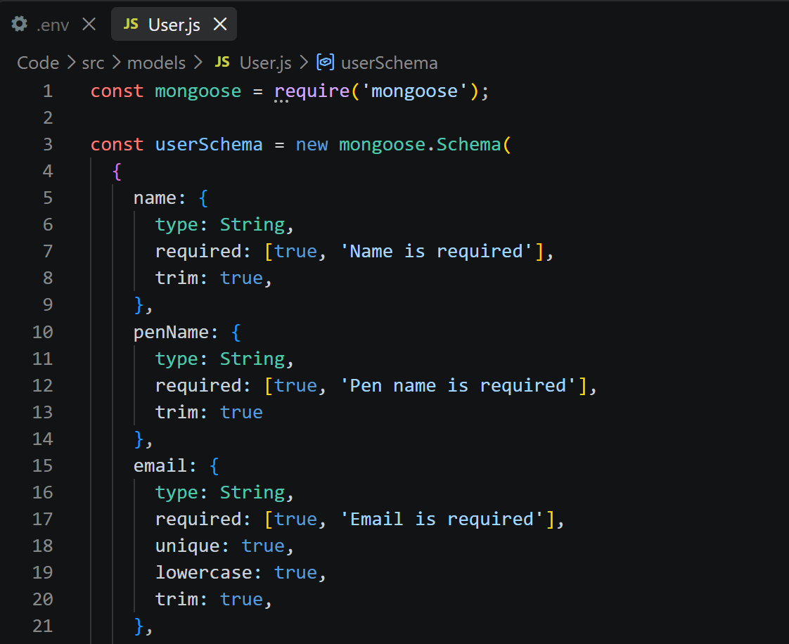
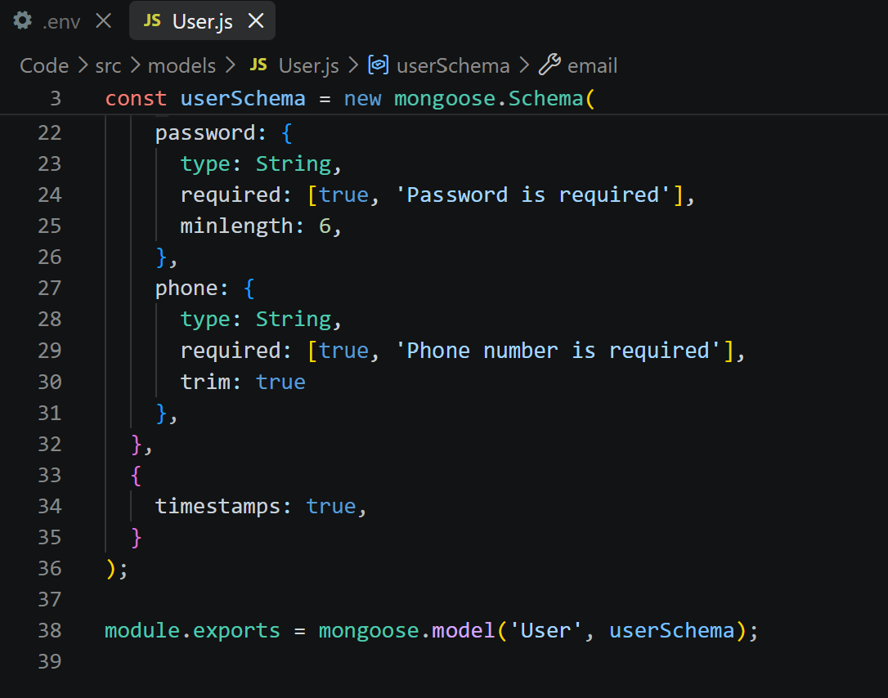

Epic 5: Project Executions:
- Install Postman or ThunderClient (VS Code extension).
- Start the backend server:
“npm run dev”

API Testing :
User Registration :
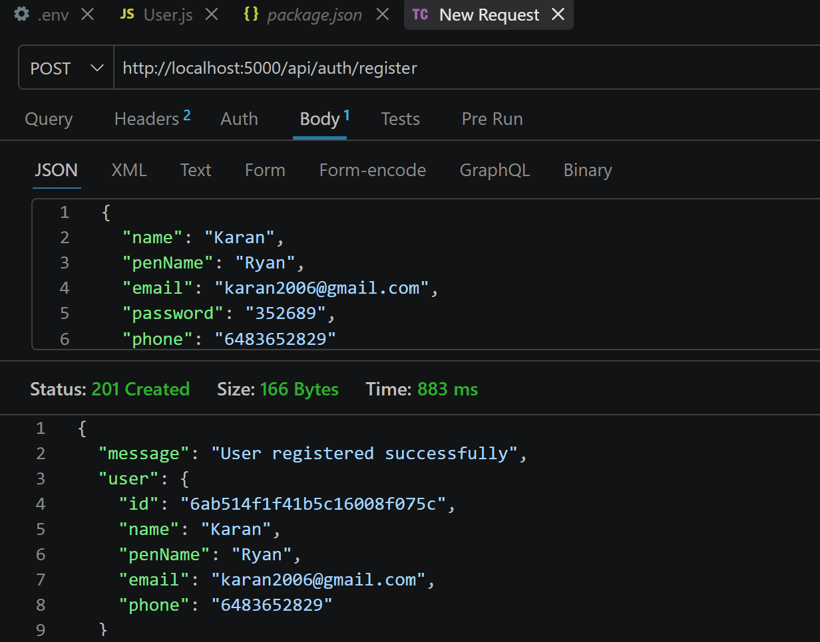
User Login:
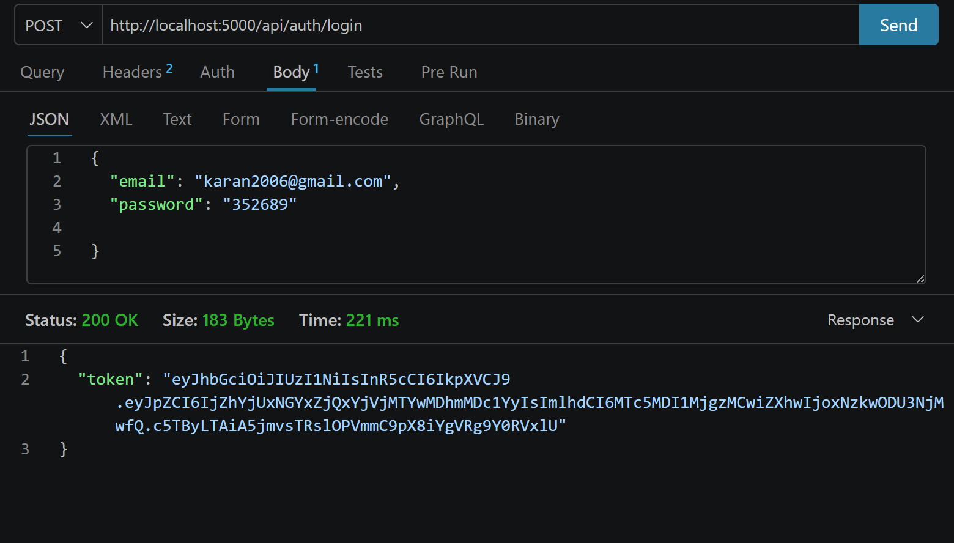
Create Blogs :
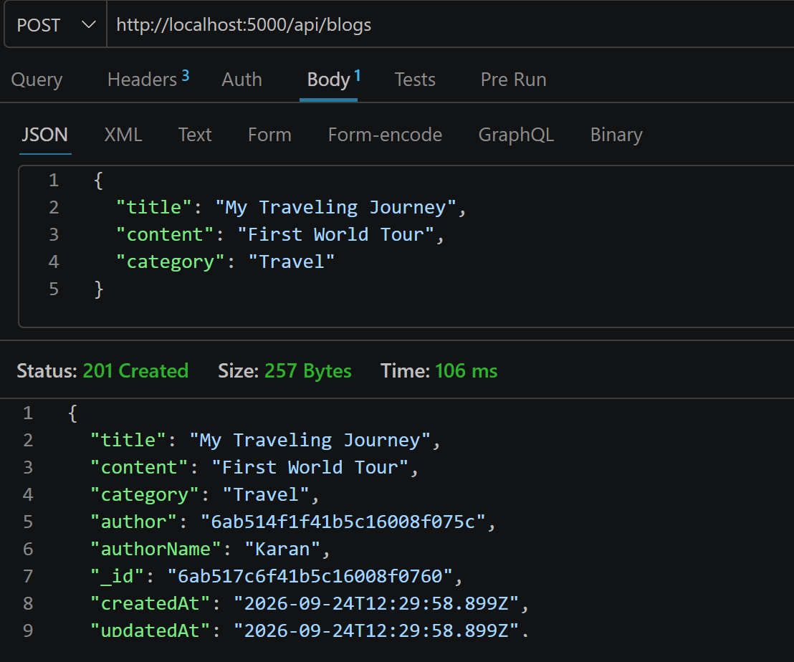

Fetch Blogs :
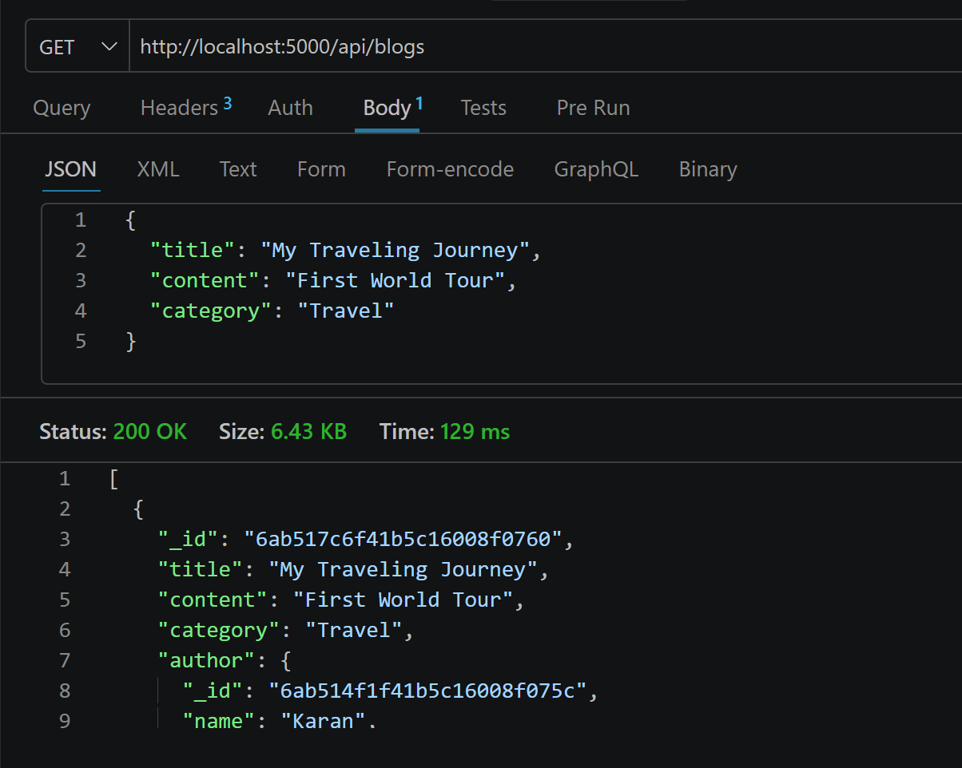

Generate AI blogs :
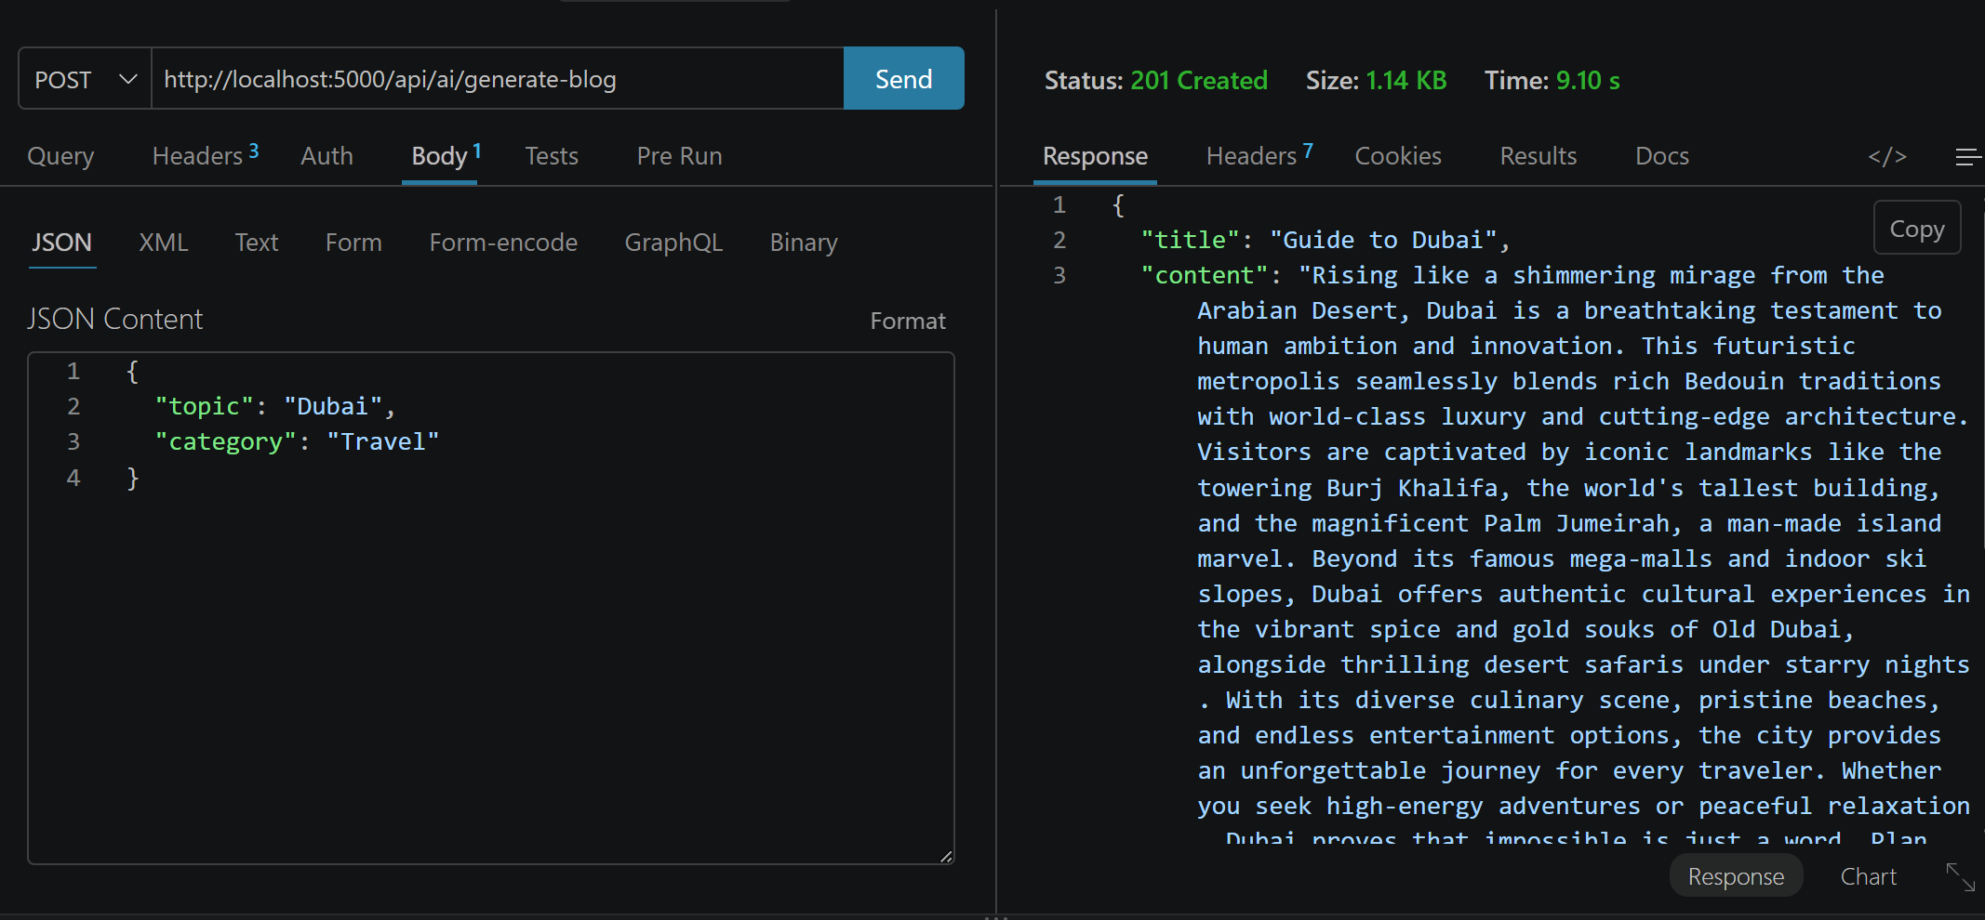
Summarize Blogs : 